
ISSN : 2797-0612
E-ISSN : 2776-6489
DOI : doi.org/10.28926/sinda.v4i2.2180

Sustainability Business Strategy in the Era of VUCA: Dynamic Capability Perspective
Denny Rakhmad Widi Ashari ⁽¹⁾, Gautama Sastra Waskita ⁽²⁾
¹ Universitas Nahdlatul Ulama Blitar, Indonesia
² Universitas Tulungagung, Indonesia
Email: ¹ drwashari@unublitar.ac.id, ² sastrawaskita@unita.ac.id
Article Information |  | ABSTRACT
Received : 31 Maret 2025  Published : 05 April 2025 |  | Sustainability Business Strategy in the Era of VUCA: Dynamic Capability Perspective. The increasing uncertainty and complexity in the business environment, often described as the VUCA (volatility, uncertainty, complexity, and ambiguity) era, pose significant challenges for small and medium-sized enterprises (SMEs) in sustaining their competitive advantage. While sustainability-driven business strategies have been widely acknowledged as a means to enhance long-term resilience, the role of dynamic capabilities in enabling SMEs to navigate sustainability challenges remains underexplored. This study aims to investigate how SMEs develop sustainable business strategies through dynamic capability mechanisms (sensing, seizing, and transforming), using Kedai Kosim, Indonesia, as a case study. Employing a qualitative approach with in-depth interviews and document analysis, this research reveals that strategic agility, stakeholder collaboration, and digital transformation are key enablers of sustainability in resource-constrained firms. The findings extend the dynamic capability theory by contextualizing it within SME sustainability strategies and offer practical insights for business practitioners and policymakers. The study suggests that SMEs can achieve sustainability by embedding it into core business models, leveraging technology, and fostering ecosystem partnerships. This research contributes to the ongoing discourse on sustainability and strategic agility in SMEs, highlighting the need for further empirical exploration across different industries and cultural contexts.
Keywords:
Sustainability strategy
Dynamic capability
VUCA
SMEs
Strategic Agility

Informasi Artikel |  | ABSTRAK
Keyword:  Strategi keberlanjutan  Kapabilitas dinamis  VUCA  UMKM  Ketangkasan Strategis |  | Ketidakpastian dan kompleksitas yang semakin meningkat dalam lingkungan bisnis, yang sering disebut sebagai era VUCA (volatility, uncertainty, complexity, and ambiguity), menimbulkan tantangan besar bagi usaha kecil dan menengah (UKM) dalam mempertahankan keunggulan kompetitifnya. Meskipun strategi bisnis berbasis keberlanjutan diakui sebagai cara untuk meningkatkan ketahanan jangka panjang, peran kapabilitas dinamis dalam membantu UKM menghadapi tantangan keberlanjutan masih belum banyak diteliti. Penelitian ini bertujuan untuk mengkaji bagaimana UKM mengembangkan strategi bisnis berkelanjutan melalui mekanisme kapabilitas dinamis (sensing, seizing, dan transforming) dengan studi kasus pada Kedai Kosim, Indonesia. Dengan menggunakan pendekatan kualitatif melalui wawancara mendalam dan analisis dokumen, penelitian ini menemukan bahwa kelincahan strategis, kolaborasi pemangku kepentingan, dan transformasi digital menjadi faktor kunci dalam mencapai keberlanjutan bagi perusahaan dengan sumber daya terbatas. Temuan ini memperluas teori tentang kapabilitas dinamis dengan mengontekstualisasikannya dalam strategi keberlanjutan UKM serta memberikan implikasi praktis bagi praktisi bisnis dan pembuat kebijakan. Studi ini menyarankan bahwa UKM dapat mencapai keberlanjutan dengan mengintegrasikannya ke dalam model bisnis inti, memanfaatkan teknologi, dan membangun kemitraan ekosistem. Penelitian ini berkontribusi pada diskusi akademik mengenai strategi keberlanjutan dan ketangkasan strategis dalam UKM, serta membuka peluang eksplorasi lebih lanjut di berbagai industri dan konteks budaya.

Introduction
In today's rapidly evolving business landscape, characterized by volatility, uncertainty, complexity, and ambiguity (VUCA), organizations face unprecedented challenges in maintaining competitiveness and ensuring long-term sustainability. The dynamic nature of global markets necessitates that businesses not only adapt to constant changes but also proactively anticipate and respond to emerging opportunities and threats. This imperative has led to a growing emphasis on integrating sustainability into core business strategies, leveraging dynamic capabilities to navigate the complexities of the VUCA environment (Teece, 2018).
Dynamic capabilities, defined as a firm's ability to integrate, build, and reconfigure internal and external competencies to address rapidly changing environments, have become central to strategic management discourse (Waskita, Ashari, Al Haris, et al., 2024). These capabilities enable organizations to sense opportunities and threats, seize opportunities, and transform their resource base to maintain competitiveness. In the context of sustainability, dynamic capabilities facilitate the incorporation of environmental and social considerations into business operations, thereby aligning organizational objectives with broader societal goals. This alignment not only enhances corporate reputation but also contributes to sustained competitive advantage (Andreis et al., 2024).
The integration of sustainability into business strategy through dynamic capabilities is particularly pertinent for small and medium-sized enterprises (SMEs) in emerging economies (Acosta et al., 2016; Eldon & Waskita, 2024). These enterprises often operate in resource-constrained settings and face unique challenges in implementing sustainable practices. However, by developing dynamic capabilities, SMEs can effectively respond to environmental uncertainties and stakeholder expectations, turning potential constraints into opportunities for innovation and growth. This approach underscores the importance of viewing sustainability not as a static compliance requirement but as a dynamic capability that drives continuous improvement and value creation (Patterson et al., 2022).
Despite the recognized importance of dynamic capabilities in achieving corporate sustainability, there remains a paucity of empirical studies examining this relationship, especially within the context of SMEs in developing countries. Existing research has predominantly focused on large corporations in developed economies, leaving a significant gap in understanding how smaller firms can leverage dynamic capabilities for sustainable development. Addressing this gap is crucial, as SMEs constitute a substantial portion of the global economy and play a vital role in driving sustainable development (Waskita & Ashari, 2025).
This study aims to explore how SMEs in emerging markets can develop and utilize dynamic capabilities to formulate and implement sustainable business strategies in a VUCA environment (Baran & Woznyj, 2020). By examining the case of Kedai Kosim, a local coffee enterprise in Indonesia, this research seeks to provide insights into the processes and practices that enable SMEs to integrate sustainability into their core operations effectively (Waskita, Ashari, Al Haris, et al., 2024). Through this case study, the research will identify the specific dynamic capabilities that facilitate the adoption of sustainable practices and assess their impact on organizational performance and resilience.
The findings of this study are expected to contribute to the literature on dynamic capabilities and corporate sustainability by providing empirical evidence from the SME context in a developing country (Sartono et al., 2021). Furthermore, the research will offer practical implications for SME managers and policymakers, highlighting strategies to build and enhance dynamic capabilities for sustainability (Waskita & Ashari, 2025). By understanding the mechanisms through which dynamic capabilities influence sustainable business practices, organizations can better navigate the complexities of the VUCA environment and achieve long-term success.
In conclusion, as businesses continue to confront the challenges of a VUCA world, the development of dynamic capabilities emerges as a critical factor in achieving corporate sustainability. For SMEs in emerging economies, this entails a strategic focus on building the capacity to sense, seize, and transform in response to environmental changes. By embedding sustainability into their dynamic capabilities, these enterprises can not only enhance their competitiveness but also contribute to broader societal goals, thereby ensuring their relevance and success in the evolving global marketplace.
Problem Statement
The increasing volatility, uncertainty, complexity, and ambiguity (VUCA) in the global business environment pose significant challenges for enterprises striving for long-term sustainability. Small and medium-sized enterprises (SMEs), particularly in developing economies, are disproportionately affected by these uncertainties due to their limited resources, financial constraints, and restricted access to strategic capabilities (Teece, 2018). The coffee industry, a crucial sector in Indonesia’s economy, is not immune to these challenges. SMEs in this sector face fluctuating market demands, price volatility, supply chain disruptions, and regulatory uncertainties, all of which threaten business continuity and sustainability (Waskita, Ashari, Al Haris, et al., 2024). Despite these adversities, some SMEs, such as Kedai Kosim, have demonstrated resilience and continued growth. However, the mechanisms through which such businesses develop and sustain competitive advantage in a VUCA environment remain underexplored.
Existing research has extensively examined sustainable business strategies in large corporations, focusing on their ability to integrate sustainability into long-term planning (Tu & Wu, 2021). However, there is a notable gap in the literature regarding how SMEs especially those in the coffee industry leverage dynamic capabilities to navigate a VUCA landscape while ensuring sustainable business practices. Studies on dynamic capabilities have predominantly centered on high-tech and manufacturing firms, neglecting the unique strategic challenges faced by SMEs in traditional industries (Wilden et al., 2016). Understanding how SMEs in the coffee sector develop adaptive strategies, reconfigure resources, and respond to environmental uncertainties is crucial for expanding the theoretical and practical discourse on business sustainability.
Furthermore, while the concept of dynamic capabilities which includes the ability to sense, seize, and transform in response to external changes has been recognized as a key determinant of firm adaptability, its specific application in the context of sustainability-driven SMEs in emerging markets remains understudied (Teece, 2007). The role of dynamic capabilities in fostering resilience and sustainability in the Indonesian coffee industry, particularly within partnership-based business models such as Kedai Kosim’s, is an area that demands deeper investigation. How do these capabilities enable SMEs to remain competitive amidst economic uncertainties? What strategic processes underpin the ability of SMEs like Kedai Kosim to maintain sustainability in an unpredictable business environment? Addressing these questions is imperative for both academic research and managerial practice.
This study seeks to bridge these gaps by investigating how Kedai Kosim, as a representative case of an SME in Indonesia’s coffee sector, employs dynamic capabilities to achieve sustainable business outcomes in a VUCA context. By focusing on Kedai Kosim’s strategic agility, partnership model, and sustainability-driven innovations, this research will provide empirical insights into the broader implications of dynamic capabilities for SMEs navigating uncertain business environments. The findings will contribute to the theoretical development of sustainability strategies in SMEs while offering practical guidance for business practitioners and policymakers seeking to enhance SME resilience in emerging economies.
Research Objectives
In an era characterized by volatility, uncertainty, complexity, and ambiguity (VUCA), businesses particularly small and medium-sized enterprises (SMEs) must develop adaptive strategies to ensure long-term sustainability. The ability to respond to dynamic environmental changes through the development of dynamic capabilities has been recognized as a key determinant of business resilience and sustainability (Teece, 2018). However, while large corporations have been extensively studied in this regard, research on how SMEs, especially in emerging economies, leverage dynamic capabilities for sustainability remains limited (Wilden et al., 2016). This study aims to address this gap by investigating how Kedai Kosim, a partnership-based coffee enterprise in Indonesia, employs dynamic capabilities to achieve sustainable business growth within a VUCA environment. Specifically, this research will focus on the following objectives:
- To analyze the sustainability strategies implemented by Kedai Kosim in response to VUCA challenges
This objective seeks to identify the key sustainability practices adopted by Kedai Kosim to enhance business resilience. Given the increasing market uncertainties, understanding how SMEs in the coffee industry develop and implement sustainability strategies is critical for both academic and practical insights (J. Barney, 1991).
- To examine the role of dynamic capabilities in enabling Kedai Kosim to maintain competitiveness and long-term sustainability
This research will explore the specific dynamic capabilities (sensing, seizing, and transforming) that Kedai Kosim utilizes to adapt to environmental uncertainties. Prior research has largely focused on large multinational firms, leaving a gap in understanding how SMEs, with their limited resources, can develop and mobilize dynamic capabilities for sustainability (Teece, 2007).
- To identify the strategic processes through which SMEs in the coffee sector integrate sustainability and agility into their business models
By examining Kedai Kosim’s business model, this study aims to provide an in-depth understanding of how sustainability and agility can be operationalized simultaneously. The findings will contribute to the strategic management literature by shedding light on the intersection of dynamic capabilities, sustainability, and business agility in the SME context (Kurniawan et al., 2024).
- To provide empirical insights and practical recommendations for SMEs in the coffee industry on adaptive strategies for business resilience
Beyond theoretical contributions, this study seeks to offer actionable insights for SME managers and entrepreneurs. By understanding the mechanisms through which Kedai Kosim sustains its business in a challenging environment, other SMEs can develop adaptive strategies tailored to their own operational contexts (Wilden et al., 2016).
- To contribute to the academic literature on sustainable business strategy by contextualizing the role of dynamic capabilities in SMEs in emerging economies
Given the limited empirical research on SMEs in developing countries, this study will enhance the theoretical discourse on dynamic capabilities and sustainability within the Indonesian coffee industry. By bridging this gap, the research will inform both scholars and practitioners on how SMEs can thrive in a VUCA landscape.
By achieving these objectives, this study aims to provide a comprehensive understanding of how SMEs, particularly those operating in volatile industries, can leverage dynamic capabilities to enhance sustainability and business resilience. The findings will offer significant contributions to both theory and practice, addressing critical gaps in strategic management and SME sustainability research.
Gap Analysis
Sustainability has become a critical component of contemporary business strategy, with research extensively examining how firms integrate sustainable practices into their operations. Prior studies emphasize that businesses adopting sustainability-driven strategies can achieve competitive advantages, enhance financial performance, and build long-term resilience (J. Barney, 1991; Teece, 2018). Large corporations have been at the forefront of sustainability research, leveraging their extensive resources to embed sustainability principles into business models. However, SMEs) face unique challenges due to limited financial and managerial resources, making it difficult to implement robust sustainability strategies (Kurniawan et al., 2024).
Parallel to sustainability research, the concept of dynamic capabilities defined as a firm’s ability to sense, seize, and transform in response to environmental changes has gained significant attention in strategic management (Teece, 2007). Scholars argue that firms with strong dynamic capabilities are better positioned to navigate uncertain environments, exploit emerging opportunities, and sustain long-term competitiveness (Wilden et al., 2016). While research on dynamic capabilities has advanced in high-tech and large-scale industries, its application to SMEs, particularly in traditional sectors such as coffee businesses, remains underexplored. Despite extensive discussions on sustainability strategies and dynamic capabilities, several research gaps persist:
- Lack of SME-Focused Research on Sustainability in VUCA Environments
Most studies on sustainability strategies focus on multinational corporations and large enterprises (J. B. Barney et al., 2021). SMEs, particularly in emerging markets, operate under different constraints and require distinct strategic approaches. The role of sustainability in SMEs, especially within volatile industries like coffee, has not been sufficiently explored.
- Limited Empirical Evidence on the Role of Dynamic Capabilities in SME Sustainability
While dynamic capabilities have been widely examined in large firms, little is known about how SMEs develop and leverage these capabilities to integrate sustainability into their business models (Teece, 2018). Research on how SMEs sense, seize, and transform sustainability opportunities remains fragmented, particularly in non-technological sectors.
- Insufficient Studies on Emerging Market SMEs and Industry-Specific Insights
Most existing literature is centered on developed economies, neglecting the unique challenges and opportunities faced by SMEs in developing countries like Indonesia (Wilden et al., 2016). The coffee industry, a key contributor to Indonesia’s economy, requires context-specific insights to understand how sustainability-driven SMEs survive in a VUCA environment.
- Limited Research on Sustainability Strategies in Partnership-Based Business Models
Business models that emphasize partnerships, such as Kedai Kosim’s, have not been adequately studied within the context of sustainability and dynamic capabilities. Understanding how SMEs collaborate within ecosystems to enhance sustainability presents a valuable research avenue.

Addressing these research gaps, this study aims to make several key contributions:
- Extending the Understanding of Sustainability in SMEs
By focusing on Kedai Kosim, this study will provide empirical evidence on how sustainability is operationalized in an SME setting within an emerging economy. This contribution helps bridge the knowledge gap regarding SME sustainability strategies beyond large corporate contexts.
- Advancing the Application of Dynamic Capabilities in SME Sustainability
This research will explore how Kedai Kosim applies the dynamic capabilities framework to enhance sustainability in a VUCA environment, offering new insights into how SMEs build adaptability and resilience through strategic agility.
- Providing Industry-Specific Insights for the Coffee Sector
By examining a coffee-based SME, this study will contribute to the limited research on sustainability within the coffee industry, offering practical implications for SMEs operating in similar sectors.
- Offering Practical Implications for SMEs and Policymakers
The findings will provide actionable recommendations for SME managers on how to integrate dynamic capabilities into sustainability strategies, while also informing policymakers on how to create supportive ecosystems for SME sustainability in emerging markets.
Through this research, the study aims to fill the existing gaps in the literature and contribute to a more comprehensive understanding of how SMEs can achieve sustainability by leveraging dynamic capabilities in an unpredictable business environment.
Novelty and Research Justification
The increasing unpredictability of business environments in the era of volatility, uncertainty, complexity, and ambiguity (VUCA) has heightened the urgency for sustainable business strategies, particularly for small and medium-sized enterprises (SMEs) (Teece, 2018). While existing research has extensively explored sustainability strategies and dynamic capabilities in large multinational firms, there remains a significant gap in understanding how SMEs, especially in traditional industries like coffee, develop resilience and long-term sustainability. This study seeks to fill this gap by providing a novel and context-specific analysis of how dynamic capabilities enable sustainability in Indonesian SMEs, using Kedai Kosim as a unit of analysis. The research introduces several key novelties:
1. Integrating Dynamic Capabilities and Sustainability in an SME Context
While dynamic capabilities theory has been widely applied in high-tech and manufacturing firms, its role in sustainability-driven SMEs in emerging economies remains underexplored (Wilden et al., 2016). This study advances the discourse by explicitly linking dynamic capabilities (sensing, seizing, and transforming) with sustainability strategies in the SME sector, offering a fresh perspective on how smaller firms navigate uncertain environments through strategic adaptability (Teece, 2007).
2. Empirical Contribution to Sustainability Strategies in the Coffee Industry
Most studies on sustainability focus on large corporations or high-tech sectors, while research on sustainability practices in SMEs within the coffee industry remains limited (Kurniawan et al., 2024). By investigating Kedai Kosim, a partnership-based coffee enterprise in Indonesia, this research provides industry-specific insights into how sustainability can be integrated into traditional sectors. This contributes to a deeper understanding of sustainability in agricultural and retail-oriented businesses.
3. Contextualizing Dynamic Capabilities in Emerging Market SMEs
Current research on dynamic capabilities is predominantly conducted in developed economies, leaving a theoretical and empirical gap regarding its application in emerging markets like Indonesia (J. B. Barney et al., 2021). This study enriches the literature by demonstrating how SMEs in developing countries leverage dynamic capabilities to overcome resource constraints and regulatory uncertainties. The findings will offer a contextualized framework for sustainability strategies in SMEs operating in volatile market conditions.
4. Exploring Sustainability within a Partnership-Based Business Model
Kedai Kosim operates under a unique partnership-based business model, wherein sustainability is embedded not only in internal operations but also in collaborative networks (Waskita & Ashari, 2024). Existing research has primarily examined sustainability in stand-alone business models, whereas this study explores how SME partnerships contribute to sustainable business practices. This perspective offers novel insights into ecosystem-based sustainability strategies in SMEs.
5. Bridging the Gap Between Theory and Practice for SMEs in the VUCA Era
Unlike prior research that tends to focus on theoretical frameworks, this study employs a practical, case-based approach to examine real-world business challenges. By offering actionable insights, this research bridges the gap between academic theory and managerial practice, providing SMEs with a strategic framework to enhance sustainability through dynamic capabilities (Teece, 2018). The findings will also be valuable for policymakers seeking to foster SME resilience in emerging markets.
6. Advancing the Concept of Strategic Agility in SMEs
While strategic agility has been explored in the context of large firms, little is known about how SMEs apply agility to maintain sustainability in turbulent environments (Wilden et al., 2016). This study contributes to the literature by demonstrating how Kedai Kosim’s agility in sensing market shifts, seizing emerging opportunities, and transforming business models fosters long-term sustainability.

Justification of the Study
This research is justified by the following considerations:
- Theoretical Contribution
By integrating dynamic capabilities and sustainability strategies in an SME context, this study extends the theoretical framework beyond large firms, contributing to strategic management and sustainability literature.
- Empirical Significance
The study provides empirical insights into the Indonesian coffee industry, an underrepresented sector in sustainability research, and contributes to the understanding of SME resilience in emerging economies.
- Managerial Relevance
The findings offer practical recommendations for SME managers seeking to implement sustainability-driven strategies while enhancing agility in response to VUCA challenges.
- Policy Implications
The research can guide policymakers in developing frameworks to support SMEs in integrating sustainability into their business models, fostering long-term economic and environmental benefits.
By addressing these novel dimensions, this study advances the academic discourse on sustainability and dynamic capabilities, offering a robust framework for SME resilience in the face of environmental uncertainties.
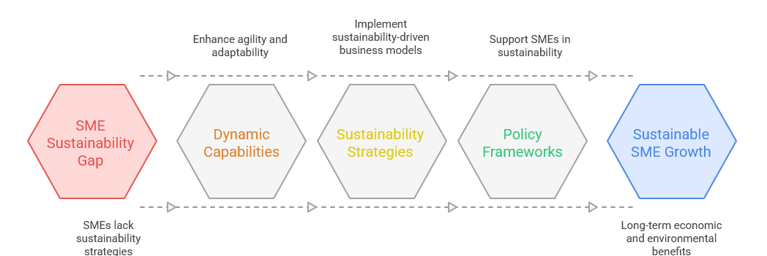
Picture 1. Integrating Sustainability in SMEs
Research Methodology
1. Research Design
This study employs a qualitative research design with a case study approach to explore how SMEs develop and implement sustainability strategies in the era of VUCA through the lens of dynamic capabilities. The case study method is particularly appropriate for understanding complex and context-specific phenomena, as it allows for an in-depth exploration of Kedai Kosim’s strategic agility and sustainability practices (Lim & Teoh, 2018). A single case study design is chosen due to the uniqueness of Kedai Kosim’s partnership-based business model, providing rich empirical insights into how an SME can achieve sustainability through dynamic adaptability (Eisenhardt & Graebner, 2007).
Given the rapidly changing business landscape, this study adopts a longitudinal perspective, analyzing Kedai Kosim’s sustainability transformation over time. This approach enables the identification of patterns in how the company responds to environmental uncertainties, regulatory changes, and shifting consumer preferences (Siggelkow, 2007).

2. Research Procedure
The research follows a structured yet flexible procedure to ensure rigor while allowing for emergent insights:
- Exploratory Phase:
  - Conducting a preliminary literature review to identify key sustainability strategies and dynamic capabilities relevant to SMEs in the coffee industry.
  - Identifying Kedai Kosim as a suitable case study based on its sustainability practices and strategic agility in a VUCA environment.
- Data Collection Phase:
  - Engaging in semi-structured interviews with key stakeholders, including Kedai Kosim’s founders, managers, baristas, and supply chain partners, to capture diverse perspectives on sustainability practices.
  - Conducting participant observations to understand the real-time decision-making process and operational strategies within the business ecosystem.
  - Collecting archival data, including company reports, social media communications, and policy documents related to sustainability initiatives.
- Data Analysis Phase:
  - Employing thematic analysis to identify recurring patterns and themes related to dynamic capabilities and sustainability strategies (Braun & Clarke, 2019).
  - Employing a rigorous thematic coding process supported by manual verification and peer debriefing to ensure analytical depth and enhance the credibility of the findings.
  - Conducting member checking to validate interpretations with research participants.
- Triangulation and Validation:
  - Ensuring methodological rigor through data triangulation, comparing insights from interviews, observations, and secondary data sources.
  - Engaging in peer debriefing with academic experts and industry practitioners to enhance the credibility of findings.
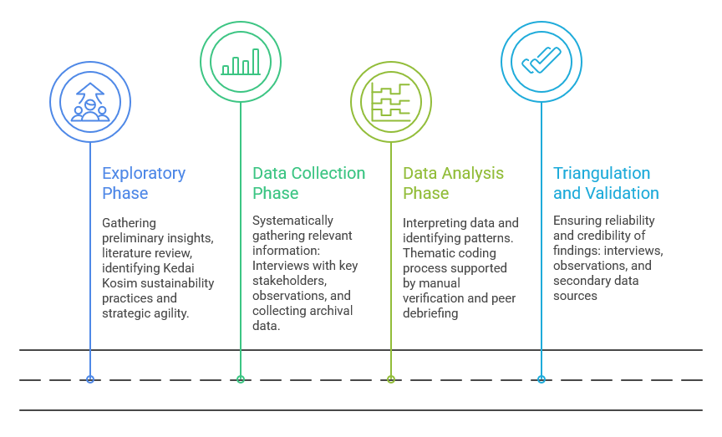
Picture 3. Research Process Stages
3. Sustainability Business Strategies in the VUCA Era
The study examines how Kedai Kosim integrates sustainability into its business model amidst VUCA conditions, focusing on three key strategic dimensions:
- Sensing Environmental Changes: Identifying emerging sustainability challenges and opportunities, such as shifting consumer preferences for ethical coffee sourcing.
- Seizing Opportunities: Developing innovative sustainability-driven initiatives, such as waste reduction, fair trade collaborations, and eco-friendly packaging.
- Transforming Business Practices: Continuously adapting supply chain processes, stakeholder partnerships, and business models to enhance long-term sustainability.
These dimensions align with the dynamic capability framework (Teece, 2018), demonstrating how SMEs navigate VUCA environments through strategic agility.
4. Data Collection Techniques
The study employs multiple data collection methods to ensure a comprehensive understanding of Kedai Kosim’s sustainability strategies:
- Semi-Structured Interviews: Conducted with business owners, managers, employees, and external stakeholders (e.g., coffee farmers, suppliers, and policymakers) to capture diverse insights into sustainability practices.
- Participant Observation: Immersion in Kedai Kosim’s daily operations to understand informal decision-making processes and sustainability-driven behaviors.
- Document Analysis: Reviewing company records, sustainability reports, and media coverage to triangulate findings and enhance validity.
- Secondary Data Analysis: Utilizing reports from the Indonesian Ministry of Cooperatives and SMEs, industry publications, and academic literature to contextualize the case study within broader market trends.
5. Literature Review and Theoretical Framework
The study builds on recent literature in sustainability, dynamic capabilities, and strategic agility to provide a robust theoretical foundation:
- Sustainability in SMEs: Research highlights that SMEs face unique barriers to sustainability, such as resource limitations and regulatory challenges (Kurniawan et al., 2024). However, strategic agility can enhance SME sustainability by enabling rapid adaptation to market changes (García-Muiña et al., 2020).
- Dynamic Capabilities in Uncertain Environments: The ability to sense, seize, and transform is critical for firms navigating uncertain environments (Teece, 2018). Recent studies suggest that SMEs leveraging dynamic capabilities can achieve superior sustainability performance despite market volatility (Wilden et al., 2016).
- Business Resilience in the VUCA Era: Research on business resilience emphasizes the role of innovation, stakeholder collaboration, and adaptability in sustaining long-term competitive advantage (J. B. Barney et al., 2021). This study contextualizes these findings within an SME setting, offering novel insights into how small firms achieve resilience through sustainability.
6. Research Validity and Reliability
To ensure the rigor of the study, the following measures are implemented:
- Construct Validity: Utilizing multiple sources of evidence (interviews, observations, and document analysis) to strengthen the robustness of findings.
- Internal Validity: Applying pattern-matching techniques to establish logical connections between sustainability strategies and dynamic capabilities.
- External Validity: Positioning findings within broader sustainability and SME literature to enhance generalizability to similar business contexts.
- Reliability: Maintaining an audit trail of all research processes, including interview transcripts, coding procedures, and data analysis protocols, to ensure consistency and replicability.

Results and Discussion
1. Interpretation of Results
The findings of this study reveal that Kedai Kosim’s approach to sustainability in the era of VUCA is heavily dependent on its dynamic capabilities, particularly in three interrelated areas: sensing environmental changes, seizing strategic opportunities, and transforming business practices (Teece, 2018). These capabilities allow Kedai Kosim to remain agile and resilient despite external uncertainties, such as fluctuating coffee supply chains, shifting consumer preferences, and evolving sustainability regulations.
Sensing Environmental Changes
Kedai Kosim demonstrates a strong ability to anticipate sustainability-related trends and challenges, which is a critical factor in its long-term success (Waskita, Ashari, Al Haris, et al., 2024). By continuously monitoring consumer preferences, government regulations, and industry innovations, Kedai Kosim proactively adapts its strategies (Waskita, 2019). Interviews with the management revealed that the rising demand for ethically sourced and environmentally friendly coffee products has led the company to shift towards fair trade partnerships and sustainable farming collaborations. This finding aligns with previous studies suggesting that SMEs with high sensing capabilities are better positioned to develop sustainability-oriented business models (García-Muiña et al., 2020; Waskita, 2024).
Seizing Strategic Opportunities
Once opportunities are identified, Kedai Kosim leverages its agile decision-making processes to implement sustainability-driven initiatives. For instance, the company has:
- Partnered with local coffee farmers to ensure ethically sourced beans (Waskita et al., 2024).
- Introduced eco-friendly packaging to reduce environmental waste (Waskita, 2025).
- Developed digital marketing strategies to reach sustainability-conscious consumers (Eldon et al., 2025; Gulo et al., 2025; Waskita, Ashari, Eldon, et al., 2024).
These strategies reflect how SMEs can integrate sustainability into their business models without sacrificing profitability (Kurniawan et al., 2024). The findings further support the notion that SMEs that actively engage in stakeholder collaborations and technological adoption can enhance their sustainability efforts (Faridy et al., 2025; Aneu Nurkhalifah Arhasy et al., 2024; Wilden et al., 2016).
Transforming Business Practices
The study found that Kedai Kosim continuously reconfigures its resources and business processes to adapt to a VUCA-driven environment. This transformation is evident in:
- Flexible supply chain management, ensuring resilience against supply fluctuations.
- Employee upskilling programs, focusing on sustainability awareness and ethical business practices.
- Community engagement initiatives, fostering brand loyalty and strengthening its business ecosystem.
These findings suggest that sustainability in SMEs is not just about environmental responsibility but also about strategic adaptability, which aligns with Teece’s (2018) dynamic capability theory. Kedai Kosim's ability to pivot its business operations in response to VUCA conditions highlights how SMEs can achieve sustainability while maintaining competitiveness.
2. Impact on Theory and Practice
Theoretical Contributions
This study contributes to the literature on sustainability business strategy and dynamic capabilities in SMEs by:
- Extending dynamic capability theory into the SME sustainability context, demonstrating how small businesses can leverage adaptability to drive long-term environmental and financial performance.
- Integrating sustainability with VUCA by showing that SMEs must go beyond traditional business strategies and adopt agile, flexible models to withstand market uncertainties.
- Introducing a partnership-based sustainability model that emphasizes SME collaboration with farmers, suppliers, and policymakers as a critical factor in long-term sustainability success.
Practical Implications
The findings provide actionable insights for SME practitioners:
- Embedding sustainability into business strategy: SMEs should adopt sustainability as a core strategic function rather than a peripheral initiative.
- Investing in digital transformation: Online engagement and digital marketing can enhance sustainability branding and consumer trust.
- Developing collaborative ecosystems: SMEs should strengthen multi-stakeholder partnerships to navigate market volatility effectively.
For policymakers, the study suggests that targeted regulatory support and financial incentives for SMEs investing in sustainability can foster more resilient business ecosystems.
3. Research Limitations
Methodological Constraints
- Single-case study limitation: The study focuses on Kedai Kosim, limiting generalizability to other SMEs.
- Qualitative data reliance: While rich in insights, qualitative methods may introduce interpretative biases, even with triangulation.
Contextual Limitations
- Industry-specific focus: The coffee industry has unique sustainability dynamics that may differ from other SME sectors.
- External environmental factors: Macroeconomic and regulatory changes beyond Kedai Kosim’s control may influence results.
Temporal Limitations
- Short-term study: A longitudinal approach would provide deeper insights into sustainability strategy evolution.
4. Recommendations for Future Research
- Multi-case study approach: Investigating sustainability strategies in SMEs from diverse industries.
- Longitudinal analysis: Exploring how sustainability strategies evolve over time in response to changing VUCA conditions.
- Quantitative measurement of sustainability performance: Developing frameworks to assess the financial and environmental impact of sustainability initiatives.
- Cross-cultural studies: Comparing sustainability approaches across different geographic regions and regulatory environments.
5. Social and Ethical Implications
Sustainability and Societal Well-being
- Kedai Kosim’s sustainability efforts support local farmers and ethical supply chains, contributing to social equity and economic resilience.
- The adoption of environmentally friendly practices helps reduce carbon footprints, benefiting broader societal welfare.
Ethical Considerations
- Fair trade and supplier equity: Ensuring that profit distribution remains fair across the supply chain.
- Consumer transparency: Avoiding greenwashing and maintaining ethical marketing practices.
Future Ethical Challenges
- Balancing growth with sustainability: Rapid business expansion may challenge long-term sustainability commitments.
- Managing trade-offs in profitability and ethics: SMEs must navigate the fine line between financial viability and ethical responsibility.
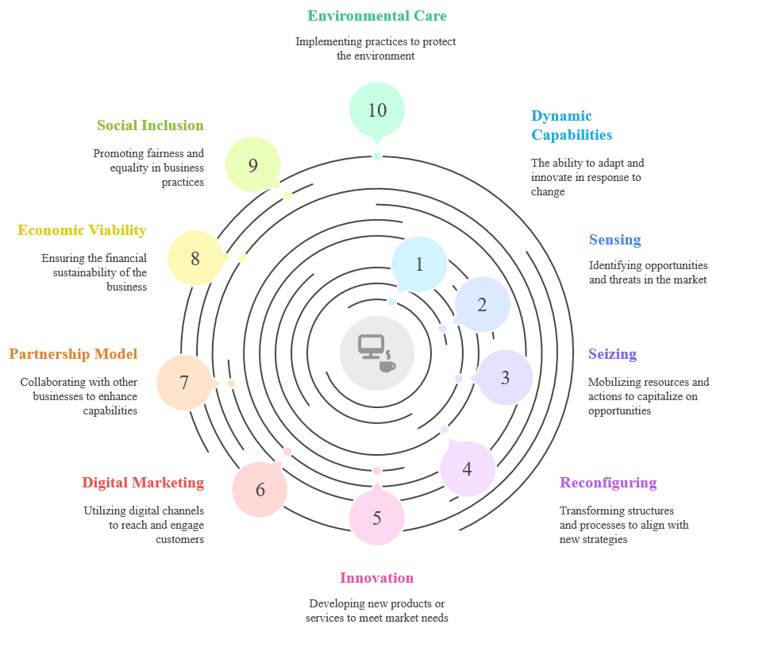
Picture 2. Navigating VUCA in Coffeepreneurship

Conclusion
This study demonstrates that dynamic capabilities are fundamental to fostering sustainable business strategies in small and medium-sized enterprises (SMEs) facing the volatility, uncertainty, complexity, and ambiguity (VUCA) of today’s business environment. By exploring Kedai Kosim’s strategic approaches within Indonesia’s coffee industry, this research reveals that sustainability is not merely a compliance obligation but a strategic asset that drives competitiveness and long-term resilience. The findings illustrate that SMEs can achieve sustainability by developing three core dynamic capabilities sensing, seizing, and transforming which enable them to anticipate market trends, capitalize on emerging opportunities, and continuously reconfigure their operations to meet environmental and social responsibilities. This adaptability, particularly within a partnership-based business model, allows SMEs like Kedai Kosim to thrive despite resource constraints and external uncertainties. The integration of sustainability into core business processes, stakeholder collaboration, and digital transformation emerges as critical pathways for SMEs to navigate the challenges of the VUCA era. By aligning business objectives with sustainability goals, SMEs can simultaneously enhance their market positioning and contribute to broader societal well-being. These insights extend the theoretical discourse on dynamic capabilities by contextualizing them within the SME sector and emerging market economies, offering valuable implications for both academia and practice.

Recommendations
For Practitioners
- Embed Sustainability into Strategic Planning: SMEs should incorporate sustainability into their strategic planning processes, recognizing it as a long-term value driver rather than an operational cost. This involves identifying and integrating sustainable practices across all levels of the business.
- Leverage Digital Technologies: Digital transformation should be prioritized to enhance market reach, operational efficiency, and engagement with sustainability-conscious consumers. Investing in digital tools can facilitate transparency, traceability, and consumer trust.
- Strengthen Partnerships and Collaboration: Building robust partnerships with suppliers, customers, and local communities can create a supportive ecosystem that fosters innovation and sustainability. Collaborative efforts can also mitigate risks associated with supply chain disruptions and regulatory changes.
For Policymakers
- Develop Supportive Regulatory Frameworks: Governments should design policies that incentivize SMEs to adopt sustainable practices. This could include tax incentives, subsidies for green technologies, and simplified compliance processes for sustainability initiatives.
- Facilitate Access to Resources and Training: Providing SMEs with access to financial resources, sustainability training programs, and technological support can empower them to implement and scale sustainable business models effectively.
- Promote Knowledge Sharing Platforms: Establishing platforms for knowledge exchange between SMEs, academia, and industry experts can enhance the diffusion of best practices and foster innovation in sustainability strategies.
For Future Research
- Explore Multi-Case Studies Across Industries: Future studies should investigate sustainability strategies in SMEs across diverse industries to validate and extend the applicability of the findings. This can provide a more comprehensive understanding of how different sectors respond to VUCA conditions.
- Incorporate Quantitative Approaches: Employing quantitative methods, such as sustainability performance metrics and financial impact assessments, can complement qualitative insights and provide a more holistic view of the business benefits associated with sustainable practices.
- Investigate Cross-Cultural Perspectives: Comparative studies across different cultural and regulatory environments can reveal how contextual factors influence the development and execution of sustainability strategies in SMEs.
In conclusion, this research underscores the importance of strategic agility and sustainability as interconnected levers for SME resilience. By understanding and leveraging dynamic capabilities, SMEs can not only secure their future in an unpredictable world but also contribute positively to sustainable development goals. Continued exploration in this field promises to unlock further pathways for small businesses to thrive sustainably, shaping a more resilient and equitable global economy.

References
Acosta, P. S., Cismaru, D.-M., Vătămănescu, E.-M., & Ciochină, R. (2016). Sustainable Entrepreneurship in SMEs: A Business Performance Perspective. Sustainability, 8(4), 342. https://doi.org/10.3390/su8040342
Andreis, F. D., Comite, U., & Gallo, A. M. (2024). Sustainable Business Model, Artificial Intelligence, and Sustainable Practices: A Possible Strategy for Tomorrow. International Journal of Academic Research in Business and Social Sciences, 14(1), Pages 60-73. https://doi.org/10.6007/IJARBSS/v14-i1/20418
Aneu Nurkhalifah Arhasy, R. R. C., Raniadita, M. A., Waskita, G. S., Rahardjo, R. S., & Stiadi, M. (2024). Kewirausahaan. Get Press Indonesia.
Baran, B. E., & Woznyj, H. M. (2020). Managing VUCA: The human dynamics of agility. Organizational Dynamics, 100787.
Barney, J. (1991). Firm resources and sustained competitive advantage. Journal of Management, 17(1), 99–120.
Barney, J. B., Ketchen Jr, D. J., & Wright, M. (2021). Resource-based theory and the value creation framework. Journal of Management, 47(7), 1936–1955.
Braun, V., & Clarke, V. (2019). Reflecting on reflexive thematic analysis. Qualitative Research in Sport, Exercise and Health, 11(4), 589–597.
Eisenhardt, K. M., & Graebner, M. E. (2007). Theory building from cases: Opportunities and challenges. Academy of Management Journal, 50(1), 25–32.
Eldon, M., Ashari, D. R. W., & Waskita, G. S. (2025). The Rise of Greenfluencers: Micro-Influencer Impact on Sustainable Product Purchase Intentions. Inovasi Pembangunan: Jurnal Kelitbangan, 13(01).
Eldon, M., & Waskita, G. S. (2024). Strategy for Improving MSMEs Through The Use of Digital Marketing During Society 5.0 and The Industrial Revolution 4.0 Era. International Seminar Universitas Tulungagung 2024, 6(2024), 823–832.
Faridy, N., Syaputra, H., Eldon, M., Sangadah, H. A., Waskita, G. S., Mulyati, Ashari, D. R. W., Ridwan, R., Azizah, N., & Noerhatini, P. (2025). Strategi Pemasaran Digital (Digital Marketing Strategy). Sada Kurnia Pustaka.
García-Muiña, F. E., Medina-Salgado, M. S., Ferrari, A. M., & Cucchi, M. (2020). Sustainability transition in industry 4.0 and smart manufacturing with the triple-layered business model canvas. Sustainability, 12(6), 2364.
Gulo, N., Ihsan, A. M. N., Eldon, M., Sangadah, H. A., Waskita, G. S., Lestari, D. F., Julaeha, L. S., Chakim, M. H. R., Devila, R., & Rachmadi, K. R. (2025). Manajemen Hubungan Pelanggan (Customer Relationship Manajemen).
Kurniawan, D., Tambunan, D. B., & Dewi, G. C. (2024). Relationships among crisis leadership, innovation capability, implementation of business continuity management, and sustainable performance in the covid-19 pandemic. The South East Asian Journal of Management, 18(1), 130–155.
Lim, Y. Y., & Teoh, A. P. (2018). The influence of sustainable leadership and strategic agility on business sustainability. Proceedings of the 7th International Conference on Entrepreneurship and Business Management (ICEBM Untar 2018), 139–144.
Patterson, E., Pugalia, S., & Agarwal, R. (2022). Innovation management as a dynamic capability for a volatile, uncertain, complex and ambiguous world. In Innovation (pp. 378–396). Routledge.
Sartono, S., Waskita, G. S., & Isro’iyah, L. (2021). Shadow Economy, Economic Development, and Entrepreneurship. INTERNATIONAL SEMINAR, 3, 73–85.
Siggelkow, N. (2007). Persuasion with case studies. Academy of Management Journal, 50(1), 20–24.
Teece, D. J. (2007). Explicating dynamic capabilities: The nature and microfoundations of (sustainable) enterprise performance. Strategic Management Journal, 28(13), 1319–1350.
Teece, D. J. (2018). Business models and dynamic capabilities. Long Range Planning, 51(1), 40–49.
Tu, Y., & Wu, W. (2021). How does green innovation improve enterprises’ competitive advantage? The role of organizational learning. Sustainable Production and Consumption, 26, 504–516.
Waskita, G. S. (2019). Pengaruh Green Marketing Mix (7Ps) Terhadap Brand Image Dan Dampaknya Pada Keputusan Pembelian Di Kedai Kosim Tulungagung. Repository Universitas Islam Kadiri.
Waskita, G. S. (2024). Pentingnya Business Plan Dalam Pengembangan Usaha. In Kewirausahaan. Get Press Indonesia.
Waskita, G. S. (2025). Turning Trash Into Treasure: Waste Banks Driving Circular Economy Through Coffee, Plastic, and Oil Waste Management. International Journal of Economic Literature, 3, 654–669.
Waskita, G. S., & Ashari, D. R. W. (2024). Building Competitive Advantage through Management Information Systems: A Managerial Perspective in the Digital Era. ESPAS - Journal of Economics and Banking, 1(1), 1–5.
Waskita, G. S., & Ashari, D. R. W. (2025). Taxation and SMEs in Emerging Markets-Case Study Approach to Compliance, Growth, and Sustainable Development. Journal of Economics and Banking ESPAS, 2(1), 1–17.
Waskita, G. S., Ashari, D. R. W., Al Haris, M. B., Rifa’i, A., & Eldon, M. (2024). Integrating Sustainable Development Goals into Coffee Shop Operations: Insights from Kedai Kosim, Indonesia. SINDA: Comprehensive Journal of Islamic Social Studies, 4(3), 243–252.
Waskita, G. S., Ashari, D. R. W., Eldon, M., & Utami, A. (2024). From Words to Actions: Exploring How e-WOM Drives Green Consumer Decisions in the Digital Age. SINDA Comprehensive Journal of Islamic Social Studies, 4(3), 253–267.
Waskita, G. S., Ashari, D. R. W., Rifa’i, A., & Al Haris, M. B. (2025). Selling in Seconds: A Phenomenological Exploration of Short Video Marketing on Instagram Reels in Entrepreneurial Ventures. International Journal of Economic Literature, 3(3), 827–842.
Wilden, R., Devinney, T. M., & Dowling, G. R. (2016). The architecture of dynamic capability research identifying the building blocks of a configurational approach. Academy of Management Annals, 10(1), 997–1076.

